GTB  
  
**QA**  
[DEV 20.18] OT-848 | XT | BENL | AS | Send to Dealer Popin v1 – 5 May 2020

**Jira ticket:**  
<https://jira.uhub.biz/browse/GTBEMEAOPT-848>

**Site**  
<https://www.nl.ford.be/>

**Test location**  
Sitewide except BP (please note it should be displayed also on TDR, unlike the original TDR Popin)

**Hypothesis**  
Analysis on the TDR Popin and UC5 has shown that TDR Popin converts at a higher rate than UC5 for TDR Completes. We know that we can expect the conversion rate to be 100% higher than onsite conversion. As such, we want to ensure we keep leveraging this popin and its audience even during the pandemic. However, we will be shifting our focus to "Contact Us" to maintain a touch-free approach.

**Test Description**

View the “BnP Start and Finish” link. Click the “Configurator” link at the top of the page in the main header. On the next page select any vehicle by clicking on them.  
  
Once you’re done the above view the “Only on profile script true” link. A popup should’ve appeared after 10 seconds. Clicking on the CTA button should take you to a deep linked page, if available. See images below.

The Popup:

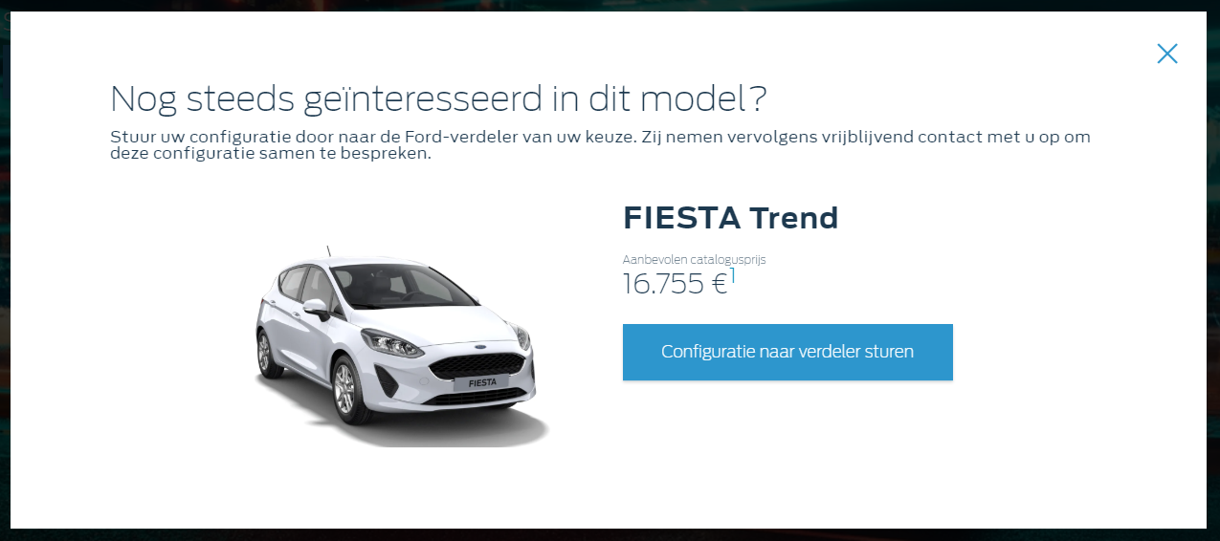

The mini popup:

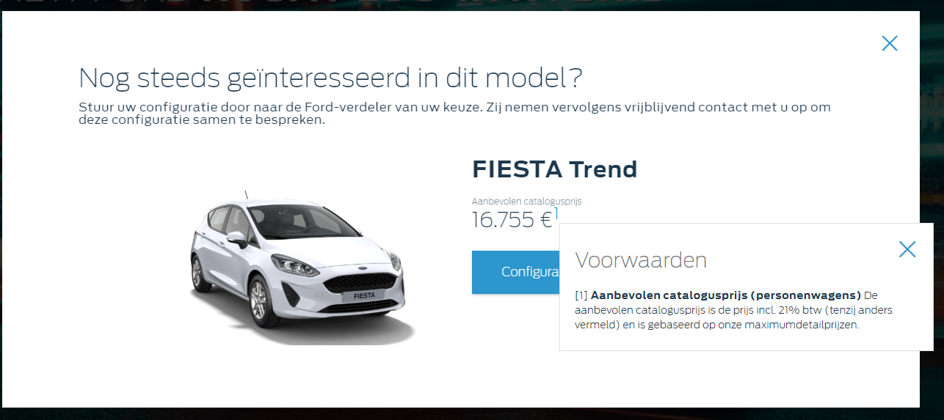

When clicking the CTA button for the Fiesta:

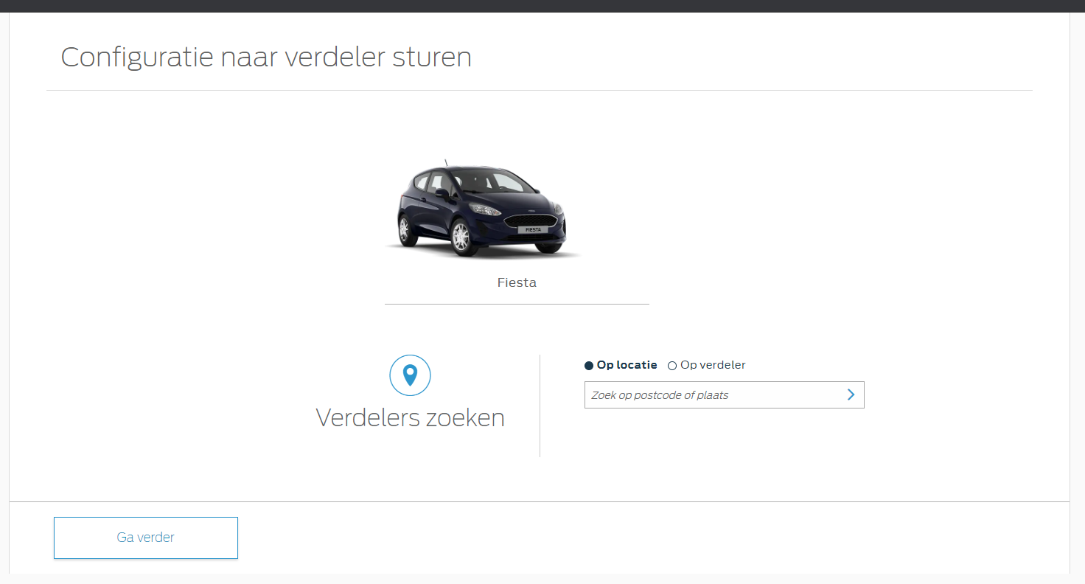

Lastly if this all works, there is one final thing to test. Go back to the BnP Start and Finish link and follow those instructions until you’re on the selected vehicle. Then click on the blue button in the top right that says “Overzicht” on the next page click on the white button that says “Configuratie naar verdeler sturen”. Once you’ve done this, open the “Only on profile script true” link again. There shouldn’t be a popup for that vehicle.

The above will also show you whether the vehicle has deep links or not. Clicking on the “Configuratie naar verdeler sturen” button will show you a popup that is either deep linked or showing the generic view with all cars to choose from.

**Browser:**   
All  
  
**Device:**   
All  
  
**Audience rules:**   
All traffic

**QA Links:**

**BnP Start and Finish**

[**https://www.nl.ford.be/?at_preview_token=rN5lPHV69l3Zydrg%2F9xfSQ%3D%3D&at_preview_index=1_1&at_preview_listed_activities_only=true**](https://www.nl.ford.be/?at_preview_token=rN5lPHV69l3Zydrg%2F9xfSQ%3D%3D&at_preview_index=1_1&at_preview_listed_activities_only=true)

**Only on profile script true**

[**https://www.nl.ford.be/?at_preview_token=rN5lPHV69l3Zydrg%2F9xfSQ%3D%3D&at_preview_index=1_2&at_preview_listed_activities_only=true**](https://www.nl.ford.be/?at_preview_token=rN5lPHV69l3Zydrg%2F9xfSQ%3D%3D&at_preview_index=1_2&at_preview_listed_activities_only=true)